Cannon II, David M.

02/02/2018

Lab Management System

Final Report

CSC 340 Computer Ethics and Sofware engineering

SPring, 2018

Table of Contents

Table of Figures 2

I. Introduction 3

1. Problem Statement 3

2. Proposal 3

II. System Description 3

III. System Requirements 3

1. Functional Requirements 3

2. Non-Functional Requirements 6

IV. Use Case Diagram 6

V. Class Diagram 7

VI. Sequence Diagrams 8

A. Sequence Diagram for Display Lab Status Use Case 8

B. Simulate Login 9

C. Simulate Logout 10

D. Refresh Lab Status 11

VII. State Diagram 12

VIII. Activity Diagrams 12

A. Display Computer Status 12

B. Simulate Login 13

C. Simulate Logout 14

D. Refresh Lab Status 15

IX. Database Design 15

A. ER Schema 15

B. Table Schema 16

X. Conclusion 16

XI. Data Dictionary 16

# Table of Figures

Figure 1 Use Case Diagram for Lab Management System 6

Figure 2 Class Diagram for Lab Management System 7

Figure 3 Sequence Diagram for Displaying the Lab Status for Lab Management System 8

Figure 4 Sequence Diagram for Simulating Login for Lab Management System 9

Figure 5 Sequence Diagram for Simulating Logout for Lab Management System 10

Figure 4 Sequence Diagram for Refreshing the Lab Status for the Lab Management System 11

Figure 6 State Diagram of Lab Management System 12

Figure 7 Activity Diagram for Displaying Lab Status for the Lab Management System 12

Figure 8 Activity Diagram for Simulating Login for the Lab Management System 13

Figure 9 Activity Diagram for Simulating Logout for the Lab Management System 14

Figure 13 Activity Diagram for Refreshing the Lab Status for the Lan Management System 15

Figure 10 ER Diagram for Database Design 15

Figure 11 Table Schema for Database Design 16

# Introduction

## Problem Statement

Students that need to use lab 430 on the fourth floor of Wallace are not always allowed to use the lab as there is a class or club using it. Other times students need to use a certain type of computer or a printer depending on the class. This causes them to hunt for the lab that has an available computer and printer that is the right type that they need.

## Proposal

This system will show available computers in the lab and what type of computer it is along with whether or not the lab has a printer. The user will be able to see if there is a class in the lab or not, allowing them to better use their time.

# System Description

The system will allow the user to view the status and schedule of Lab 430 in the Wallace building of EKU. The user will be able to see what computers are available and which types of computers are offered.

# System Requirements

## Functional Requirements

R1. The system shall display the status of the computer lab.

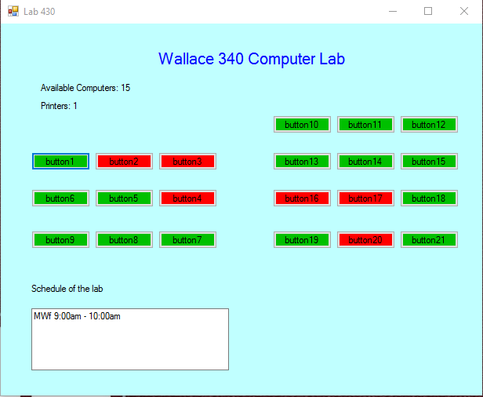

* 1. The system shall retrieve the schedule of the lab.
  2. The system shall display the status of the lab, including the schedule, availability of each computer, availability of the printers, availability of projectors, and the types of computers.
     1. If there is class in the lab, the system shall change the text box color.
     2. If the computer is idle, a green color is assigned to the computer.
     3. If the computer is occupied, a red color is assigned to the computer.
  3. The system shall retrieve the status of the computer from a database.
  4. The system shall update the status of the computer in the graphic user interface.
     1. If the computer is idle, a green color is assigned to the computer.
     2. If the computer is occupied, a red color is assigned to the computer.

R2. The system shall allow the user to refresh the status of the computer lab.

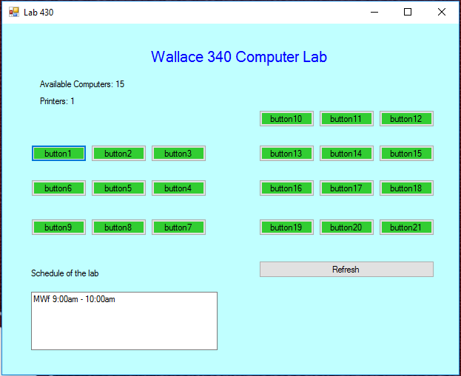

* 1. The system shall recheck the status of the lab and each computer in it if it is being used or not from the database.
  2. The system shall display the new status of the lab, including the schedule, availability of each computer, availability of the printers, availability of projectors, and the types of computers.
     1. If there is a class in the lab, the system shall display a warning message.
  3. The system shall update the status of the computer.
     1. If the computer is idle, a green color is assigned to the computer.
     2. If the computer is occupied, a red color is assigned to the computer.

R3. The system shall allow a tester to simulate the action of login to a computer.

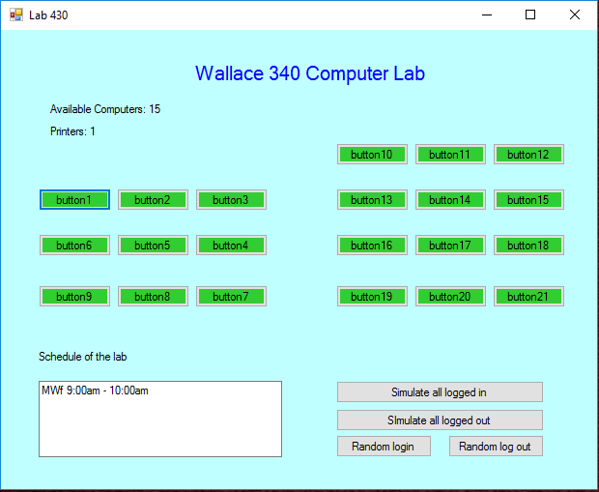

* 1. The system shall display a GUI (the status of the lab) to the tester.
  2. The tester shall be able press a button to simulate if a computer was logged into.
     1. The tester shall be able to simulate logging into each computer individually
     2. The test shall be able to simulate logging into the computers randomly.
     3. The tester shall be able to simulate all of the computers being logged into
  3. The system shall update the status of the computer.
  4. The system shall change the computer color.

R4. The system shall allow a tester to simulate the action of logout of a computer.

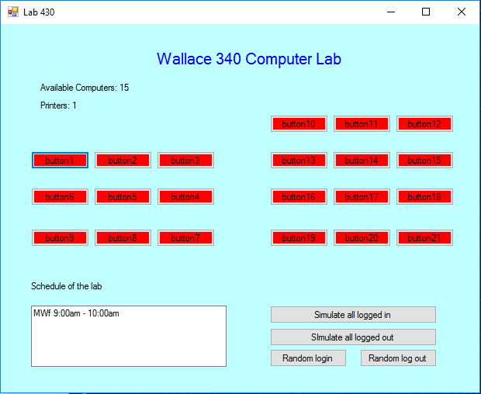

4.1 The system shall display a GUI (the status of the lab) to the tester.

4.2 The tester shall be able to press a button to simulate if a computer was logged out of.

4.2.1 The tester shall be able to simulate logging out of each individual computer.

4.2.2 The tester shall be able to simulate logging out of the computers randomly.

4.2.3 The tester shall be able to simulate logging out of all of the computers.

## Non-Functional Requirements

NR1. The system will be connected to the EKU database.

NR2. The system will update itself every five minutes.(Call Requirement Function 2.1)

# Use Case Diagram



Figure 1 Use Case Diagram for Lab Management System

This diagram shows what functions the user will have access to and what functions the tester will have access to.

# Class Diagram



Figure 2 Class Diagram for Lab Management System

This diagram shows the variables that are apart of each class.

# Sequence Diagrams

## Sequence Diagram for Display Lab Status Use Case



Figure 3 Sequence Diagram for Displaying the Lab Status for Lab Management System

This diagram shows the sequence of how the system will access the lab status to show the user

## Simulate Login



Figure 4 Sequence Diagram for Simulating Login for Lab Management System

This diagram shows the sequence to which the system will simulate logging into a computer and how that will appear to the user along with the changes that will happen within the system.

## C. Simulate Logout



Figure 5 Sequence Diagram for Simulating Logout for Lab Management System

This diagram shows the sequence to which the system will simulate logging out and the changes will happen within the system along with presenting this change to the user.

## D. Refresh Lab Status



Figure 4 Sequence Diagram for Refreshing the Lab Status for the Lab Management System

This diagram shows the sequence to how the user will refresh the lab status of lab 430.

# State Diagram



Figure 6 State Diagram of Lab Management System

This diagram shows the flow of the systems different states from start to finish.

# Activity Diagrams

## Display Computer Status



Figure 7 Activity Diagram for Displaying Lab Status for the Lab Management System

## Simulate Login



Figure 8 Activity Diagram for Simulating Login for the Lab Management System

## Simulate Logout



Figure 9 Activity Diagram for Simulating Logout for the Lab Management System

## Refresh Lab Status



Figure 13 Activity Diagram for Refreshing the Lab Status for the Lan Management System

# Database Design

## ER Schema



Figure 10 ER Diagram for Database Design

## Table Schema



Figure 11 Table Schema for Database Design

# Conclusion

This system will be beneficial to the students of EKU as it saves them time in hunting for an available computer in Lab 420 on the fourth floor of Wallace and show them how much time they have left to stay in the lab until it is used by a class.

# Data Dictionary

1. TesterActor: An actor in the use case diagram. It represents the tester who will use simulators to perform login and logout of a selected computer in the system.
2. UserActor: An actor in the use case diagram. It represents the user of the system.
3. Lab: A class used in the Domain Diagram. It will be what the labs reference.
4. Schedule: An attribute of the Lab class in the Domain Diagram.
5. Printer: An attribute of the Lab class in the Domain Diagram It represents whether or not the lab has a printer.
6. Projector: An attribute of the Lab class in the Domain Diagram. It represents whether or not the lab has a projector.
7. Computer: A class used in the Domain Diagram. It will be what the computers reference.
8. Status: An attribute of the Computer class in the Domain Diagram. It represents whether or not the computer is being used.
9. Type: An attribute of the Computer class in the Domain Diagram. It represents what operating system that the computer uses.